Hospice Niagara Office 365 Web Access Instructions
Following our recent migration to a new, expanded organizational email service, we are happy to announce that we are able to provide all staff with their own personalized Hospice Niagara Office 365 email address. Your email address is unique to you, and your password is confidential. We ask that you do not share your password with anyone.
How to access your Hospice Niagara Email via Web Access:
Your email can be accessed on any device with internet via this link: https://portal.microsoftonline.com
If you forget this link, type “Office Online Services” or “Office 365” into a search engine (such as Google) and one of the first search results will be “Sign in to Microsoft Online Services.” This is your login page.
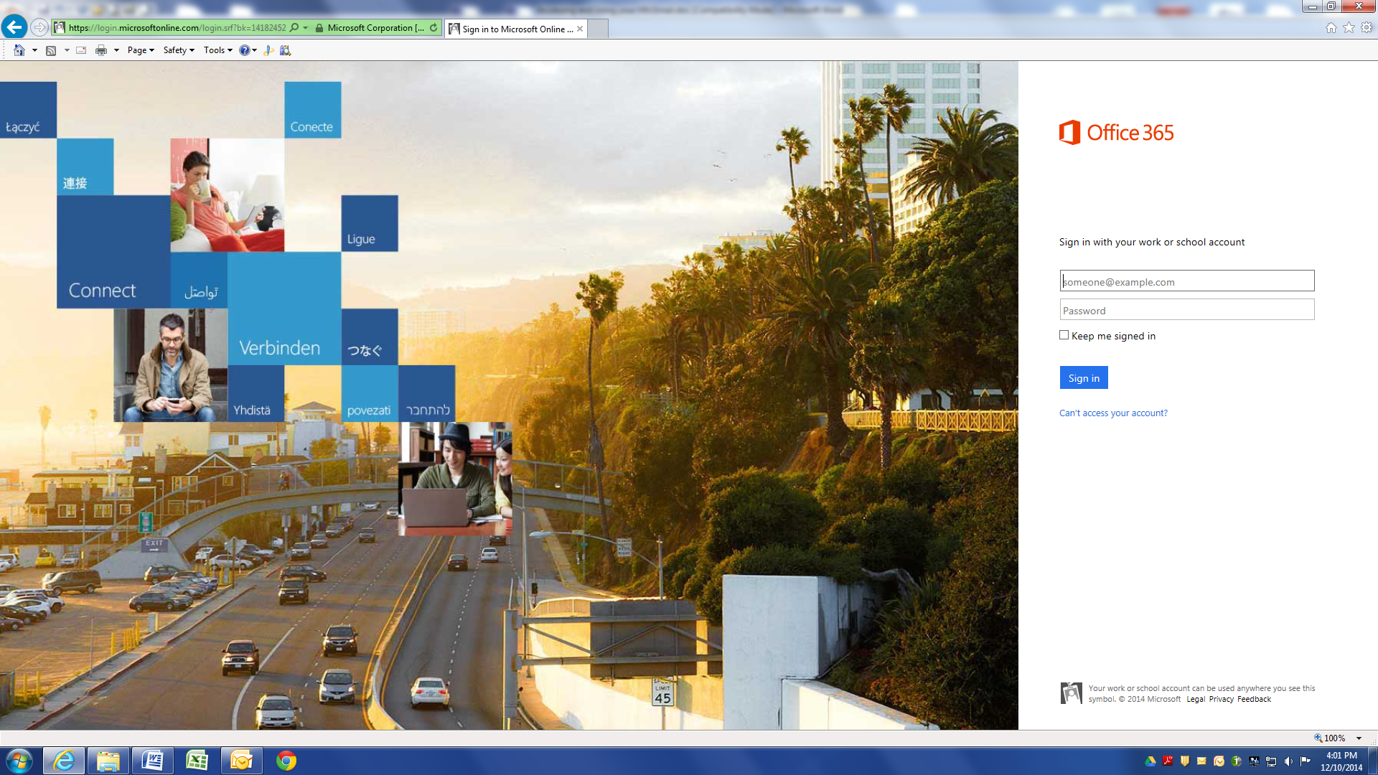

Enter your email address and password. The information is listed here:
Name: _____________________________
Email Address: _____________________________
Password: _____________________________
Upon logging in, you will see the options below. Click on Outlook to access your email, People to access all Hospice Niagara staff contacts and any contacts you have added, Calendar to view your Hospice Niagara calendar and Tasks for any job tasks that you have added for yourself.
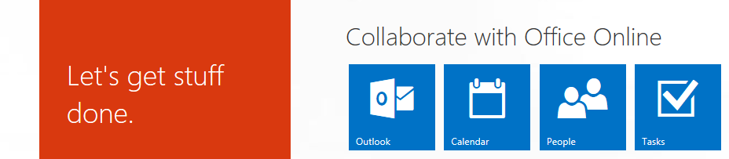

The Calendar is a really useful tool. With it, you will be able to see and keep track of Hospice Niagara related events to which you have been invited. You may accept or decline invitations and have all of the information on hand. There are further instructions on how to use the calendar, and how to share other user and room/resource calendars found in S:/Office 365 Training.

Signing Out:
Sign out of Office 365 by clicking on the Person icon at the top right of the page.
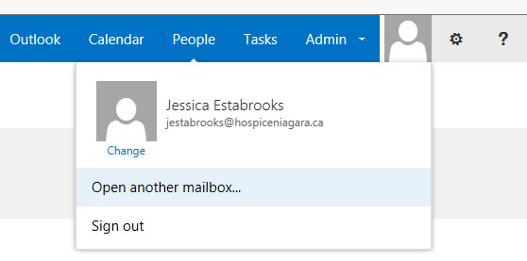

If you have any questions, contact Jessica Estabrooks at jestabrooks@hospiceniagara.ca or any of the Admin team while you are at The Stabler Centre.

